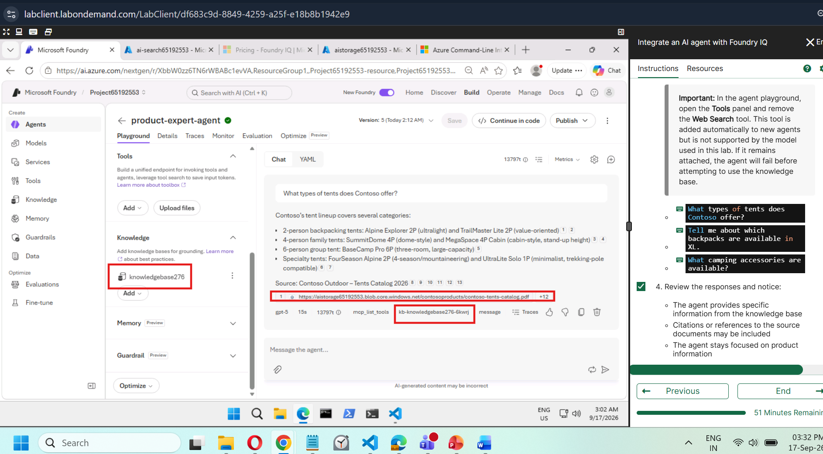
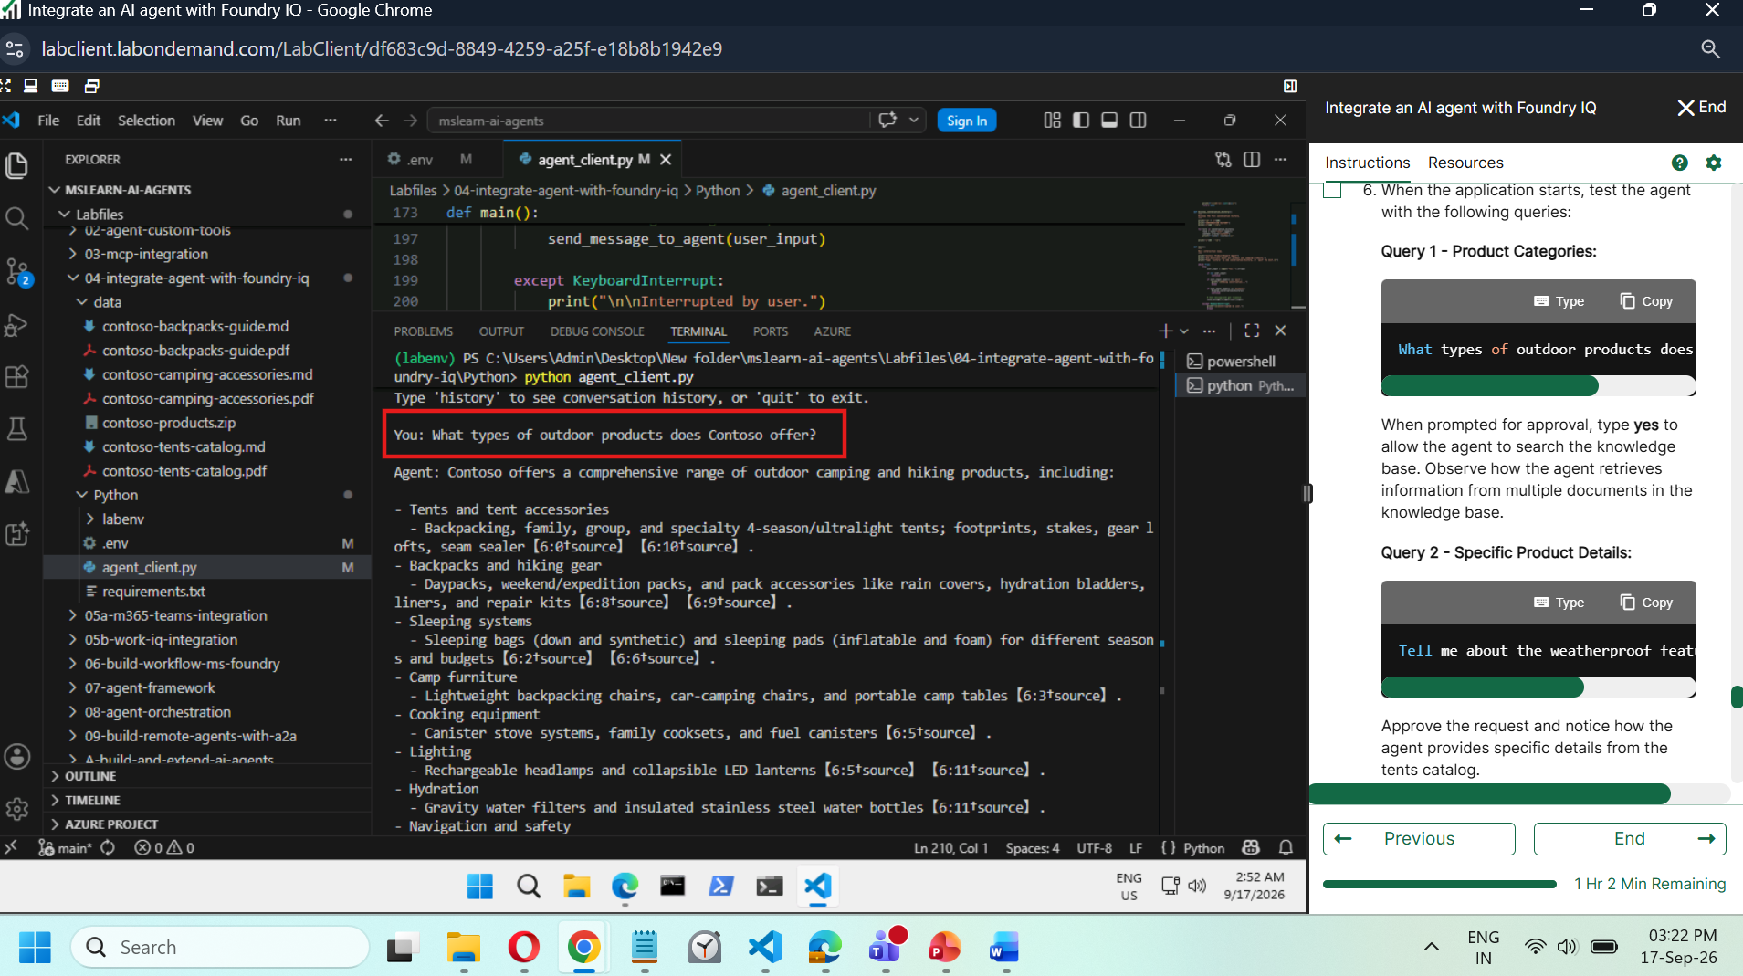

Code :

import os
from dotenv import load_dotenv
from azure.identity import DefaultAzureCredential
from azure.ai.projects import AIProjectClient

# Load environment variables
load_dotenv()
project_endpoint = os.getenv("PROJECT_ENDPOINT")
agent_name = os.getenv("AGENT_NAME")

# Validate configuration
if not project_endpoint or not agent_name:
raise ValueError("PROJECT_ENDPOINT and AGENT_NAME must be set in .env file")

print(f"Connecting to project: {project_endpoint}")
print(f"Using agent: {agent_name}\n")

# TODO: Connect to the project and create a conversation
# Add your code here to:
# 1. Create DefaultAzureCredential
# 2. Create AIProjectClient with endpoint
# 3. Get the OpenAI client
# 4. Get the agent by name
# 5. Create a new conversation
# Connect to the project and agent
credential = DefaultAzureCredential(
exclude_environment_credential=True,
exclude_managed_identity_credential=True
)
project_client = AIProjectClient(
credential=credential,
endpoint=project_endpoint
)

# Get the OpenAI client
openai_client = project_client.get_openai_client()

# Get the agent
agent = project_client.agents.get(agent_name=agent_name)
print(f"Connected to agent: {agent.name} (id: {agent.id})\n")

# Create a new conversation
conversation = openai_client.conversations.create(items=[])
print(f"Created conversation (id: {conversation.id})\n")

# Conversation history for context (client-side tracking)
conversation_history = []

def send_message_to_agent(user_message):
"""
Send a message to the agent and handle the response using the conversations API.
"""
try:
print("\nAgent: ", end="", flush=True)

# TODO: Add user message to conversation and get response
# Add your code here to:
# 1. Add the user message to the conversation using conversations.items.create()
# 2. Create a response using responses.create() with agent reference
# 3. Extract and display the response text
# 4. Check for and display any citations
# Your code will go here
# Add user message to the conversation
openai_client.conversations.items.create(
conversation_id=conversation.id,
items=[{"type": "message", "role": "user", "content": user_message}],
)

# Store in conversation history (client-side)
conversation_history.append({
"role": "user",
"content": user_message
})

# Create a response using the agent
response = openai_client.responses.create(
conversation=conversation.id,
extra_body={"agent_reference": {"name": agent.name, "type": "agent_reference"}},
input=""
)

# Loop until a response has no pending approval requests (zero, one, or many)
while True:
approval_requests = [
item for item in (getattr(response, "output", None) or [])
if getattr(item, "type", None) == "mcp_approval_request"
]

if not approval_requests:
break

approval_items = []
for approval_request in approval_requests:
print(f"[Approval required for: {approval_request.name}]\n")
print(f"Server: {approval_request.server_label}")

# Show the tool call arguments for transparency
import json
try:
args = json.loads(approval_request.arguments)
print(f"Arguments: {json.dumps(args, indent=2)}\n")
except Exception:
print(f"Arguments: {approval_request.arguments}\n")

approval_input = input("Approve this action? (yes/no): ").strip().lower()
approved = approval_input in ['yes', 'y']
print("Approving action...\n" if approved else "Action denied.\n")

approval_items.append({
"type": "mcp_approval_response",
"approval_request_id": approval_request.id,
"approve": approved
})

# Send the approval decisions and fetch the next response
openai_client.conversations.items.create(
conversation_id=conversation.id,
items=approval_items
)

response = openai_client.responses.create(
conversation=conversation.id,
extra_body={"agent_reference": {"name": agent.name, "type": "agent_reference"}},
input=""
)

# Extract the response text
if response and response.output_text:
response_text = response.output_text

print(f"{response_text}\n")

# Check for citations if available
if hasattr(response, 'citations') and response.citations:
print("\nSources:")
for citation in response.citations:
print(f" - {citation.content if hasattr(citation, 'content') else 'Knowledge Base'}")

# Store in conversation history (client-side)
conversation_history.append({
"role": "assistant",
"content": response_text
})

return response_text
else:
print("No response received.\n")
return None
except Exception as e:
print(f"\n\nError: {str(e)}\n")
return None

def display_conversation_history():
"""
Display the full conversation history.
"""
print("\n" + "="*60)
print("CONVERSATION HISTORY")
print("="*60 + "\n")

for turn in conversation_history:
role = turn["role"].upper()
content = turn["content"]
print(f"{role}: {content}\n")

print("="*60 + "\n")

def main():
"""
Main interaction loop.
"""
print("Contoso Product Expert Agent")
print("Ask questions about our outdoor and camping products.")
print("Type 'history' to see conversation history, or 'quit' to exit.\n")

while True:
try:
user_input = input("You: ").strip()

if not user_input:
continue

if user_input.lower() == 'quit':
print("\nEnding conversation...")
break

if user_input.lower() == 'history':
display_conversation_history()
continue

# Send message and get response
send_message_to_agent(user_input)

except KeyboardInterrupt:
print("\n\nInterrupted by user.")
break
except Exception as e:
print(f"\nUnexpected error: {str(e)}\n")

print("\nConversation ended.")

if __name__ == "__main__":
main()

